|  |  |
| --- | --- |
| **Exp No: 01** | **‘Creation of interactive web sites’**  **Simple HTML code to create**  **a "Sip Calculator"** |
| **Date: 12.03.24** |

**Aim:**

To create a of **interactive web sites** – This **SIP calculator** estimates **investment returns** based on **monthly investment amount, annual return rate**, and **duration**. It also considers the impact of **breaking the investment early**, including the **return percentage**.

**Algorithm:**

Algorithm for SIP Calculator:

1. Begin the algorithm.

2. Retrieve input values from the SIP calculator form:

a. Get the **monthly investment amount (amount)** in **Rupees (Rs.).**

b. Obtain the **expected annual return rate (rate)** as a **percentage.**

c. Fetch the investment duration (duration) in **years.**

d. Fetch the **investment duration before breaking (breakDuration) in years.**

e. Obtain the **percentage of return** upon breaking (breakPercentage) as a **decimal value.**

3. Convert the **annual return rate (rate)** to a monthly rate:

a. Divide the **annual return rate by 12** to obtain the monthly rate.a

4. Convert investment durations from **years to months**:

a. Multiply the investment duration (duration) by 12 to get the total number of months.

b. Multiply the **investment duration before breaking (breakDuration) by 12** to get **the total number of months before breaking**.

5. Calculate the **future value** (estimated result) of the investment without breaking:

a. Use the **future value formula** for an ordinary annuity:

**FV = PMT * ((1 + r)^n - 1) / r) * (1 + r)**

where:

- **PMT** is the **monthly investment amount.**

- **r** is the **monthly interest rate.**

- **n** is the **total number of months** (investment duration).

6. Calculate the future value (estimated result) of the investment after breaking:

a. Incorporate the **breakPercentage** into the **calculation of the future value after breaking.**

7. Calculate the total investment amount:

a. **Multiply the monthly** investment amount (amount) by the total number of months (duration).

8. Calculate the return amount after breaking:

a. Add the future value after breaking with the **difference between** the total **investment amount** and the **future value without breaking.**

9. Display the computed results on the **HTML page.**

10. End the algorithm.

**Program:**

<!DOCTYPE html>

<html lang="en">

<head>

<meta charset="UTF-8">

<meta name="viewport" content="width=device-width, initial-scale=1.0">

<title>Home Loan EMI Calculator</title>

<style>

body {

font-family: 'Segoe UI', Tahoma, Geneva, Verdana, sans-serif;

margin: 0;

padding: 0;

display: flex;

justify-content: center;

align-items: center;

height: 100vh;

background-image: url('https://insights.masterworks.com/wp-content/uploads/2022/10/iStock-1364970910-scaled.jpg'); /* Background image URL */

background-size: cover;

background-position: center;

}

.calculator {

background-color: rgba(255, 255, 255, 0.8); /* Transparent white background */

padding: 20px;

border-radius: 8px;

box-shadow: 0 0 10px rgba(0, 0, 0, 0.3);

max-width: 400px;

width: 100%;

}

.input-group {

margin-bottom: 10px;

}

.input-group label {

display: block;

font-weight: bold;

margin-bottom: 5px;

}

.input-group input {

width: 100%;

padding: 8px;

border: 1px solid #ccc;

border-radius: 4px;

box-sizing: border-box;

font-size: 16px;

}

.btn-calculate {

background-color: #4caf50;

color: #fff;

padding: 10px 20px;

border: none;

border-radius: 4px;

cursor: pointer;

width: 100%;

font-size: 16px;

}

.btn-calculate:hover {

background-color: #45a049;

}

.result {

margin-top: 20px;

background-color: rgba(255, 255, 255, 0.9); /* Transparent white background */

padding: 10px;

border-radius: 4px;

}

.result h3 {

margin-top: 0;

}

</style>

</head>

<body>

<div class="calculator">

<h2 style="text-align: center; font-size: 24px; margin-bottom: 20px;">Home Loan EMI Calculator</h2>

<div class="input-group">

<label for="loan-amount">Loan Amount (₹)</label>

<input type="number" id="loan-amount" placeholder="Enter loan amount" min="0" value="3000000" required>

</div>

<div class="input-group">

<label for="interest-rate">Interest Rate (%)</label>

<input type="number" id="interest-rate" step="0.01" placeholder="Enter interest rate" min="0" required>

</div>

<div class="input-group">

<label for="loan-term">Loan Term (years)</label>

<input type="number" id="loan-term" placeholder="Enter loan term in years" min="0" required>

</div>

<button class="btn-calculate" onclick="calculateEMI()">Calculate EMI</button>

<div class="result" id="result" style="display: none;">

<h3>Monthly EMI:</h3>

<p id="monthly-emi"></p>

<h3>Total Amount Paid:</h3>

<p id="total-amount-paid"></p>

<h3>Total Interest Paid:</h3>

<p id="total-interest-paid"></p>

<h3>Monthly Payment:</h3>

<p id="monthly-payment"></p>

</div>

</div>

<script>

function calculateEMI() {

const loanAmount = parseFloat(document.getElementById('loan-amount').value);

const interestRate = parseFloat(document.getElementById('interest-rate').value) / 100 / 12;

const loanTerm = parseFloat(document.getElementById('loan-term').value) * 12;

if (loanAmount <= 0 || interestRate <= 0 || loanTerm <= 0) {

alert("Please enter valid values for loan amount, interest rate, and loan term.");

return;

}

const monthlyEMI = (loanAmount * interestRate) / (1 - Math.pow(1 + interestRate, -loanTerm));

const totalAmountPaid = monthlyEMI * loanTerm;

const totalInterestPaid = totalAmountPaid - loanAmount;

const monthlyPayment = totalAmountPaid / loanTerm;

document.getElementById('monthly-emi').textContent = '₹' + monthlyEMI.toFixed(2);

document.getElementById('total-amount-paid').textContent = '₹' + totalAmountPaid.toFixed(2);

document.getElementById('total-interest-paid').textContent = '₹' + totalInterestPaid.toFixed(2);

document.getElementById('monthly-payment').textContent = '₹' + monthlyPayment.toFixed(2);

document.getElementById('result').style.display = 'block';

}

</script>

</body>

</html>

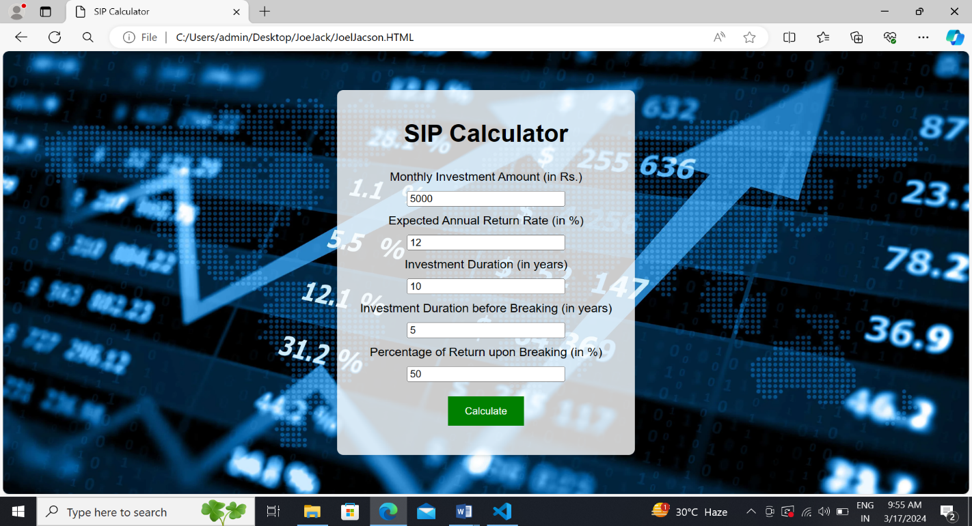**OUTPUT:**

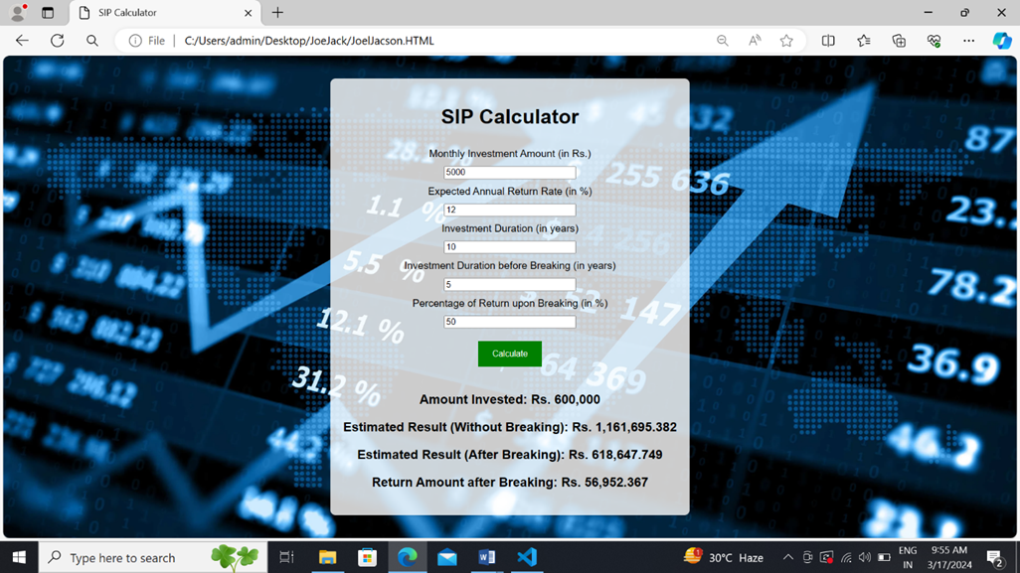

**Result:**

Thus, the **SIP calculator** application, designed using **HTML** and **authoring tools**, has been **successfully implemented.**